1. **What is a process?**

A process is a program in execution.

Multiple processes may concurrently share same CPU by storing and later reloading a process context. And independent processes cannot affect the correctness of each other’s behavior (multiple process contexts cannot exist in memory at same time).

1. **What is a thread?**

A thread is also a program in execution.

It is the smallest unit that the operating system can perform operation scheduling. Thread is included in the process and is the actual operating unit in the process. A thread refers to a single sequence of control flow in a process. Multiple threads can be concurrent in a process, and each thread executes different tasks in parallel.

1. **What is the difference between a process and a thread?**

Threads provide means of allowing blocking calls without blocking the entire process to which the thread belongs. The main difference between processes and threads is that they are different ways of operating system resource management. Processes have independent address spaces. After a process crashes, it will not affect other processes in protected mode, and threads are just different execution paths in a process. Threads have their own stacks and local variables, but there is no separate address space between threads. The death of a thread is equivalent to the death of the entire process, so multi-process programs are more robust than multi-threaded programs, but it takes time to switch processes. The larger the resources, the lower the efficiency. However, for concurrent operations that require simultaneous execution and sharing of certain variables, only threads can be used, not processes.

1. **Describe one advantage of using processes as opposed to threads.**

After a process crashes, it will not affect other processes in protected mode, and threads are just different execution paths in a process.

1. **Describe two advantages of using threads as opposed to processes.**

multi-process programs take time to switch processes, they need large resources and reduce the efficiency, and using threads can save resources.

//TODO

1. **Explain how a multithreaded server functions.**

Threads used extensively by servers in the client-server architecture. Which allows sequential processes that make blocking system calls and while still achieving parallelism.

1. **Explain what is meant by the term virtualization.**

Virtualization is a resource management technology that abstracts and transforms various physical resources of a computer, such as servers, networks and storage, to break the inseparable obstacles between physical structures. For example, every (distributed) computer system offers a programming interface to higher-level software. And the virtualization extends or replaces an existing interface so as to mimic the behavior of another system. We can use these resources in a better way by using the virtualization technique.

1. **Why is cloud computing an important application of virtualization?**

Because generally we can use these physical resources in a better way by using the virtualization technique. For example, a client will rent a virtual machine instead of renting a physical machine. But cloud computing is a concept, not a specific technology. In order to create these virtual resources, the service provider will use virtualization. Virtualization is a specific technology, which refers to the virtualization of hardware resources to achieve isolation, scalability, security, and resources that can be fully utilized. Therefore, cloud computing mostly relies on virtualization at the moment. By virtualizing multiple server entities, a resource pool is formed to realize common computing and share resources.

Because for distributed systems, an important application of virtualization lies in cloud computing, and virtualization plays a key role in each of the cloud computing services:

Infrastructure-as-a-Service (IaaS) - basic infrastructure.

Platform-as-a-Service (PaaS) - system-level services.

Software-as-a-Service (SaaS) - actual applications.

1. **Virtualization plays a key role in Infrastructure as a Service (IaaS). Justify this statement.**

Because at the moment, a client prefers to rent a virtual machine instead of renting a physical machine such as Amazon EC2.

1. **What is code migration?**

Code migration is often to transfer program codes of different platforms and different compilation environments from one machine or application to another, which is essentially different from code reusability.

The most common code migration is transfer PC algorithm to embedded system.

1. **Give an example of how code migration allows distributed systems to be dynamically configured.**

An example of dynamically configuring a client to communicate with a server shows as below:

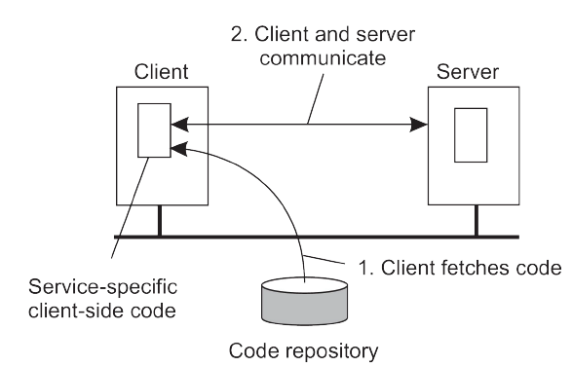

figure 1 code migration [1]

1. **Describe two challenges of code migration.**

Two challenges and their solutions:

Migrating code in heterogeneous systems. A solution -use virtualization.

Trusting downloaded code. A solution - execute code in a restricted environment called a sandbox.[1]